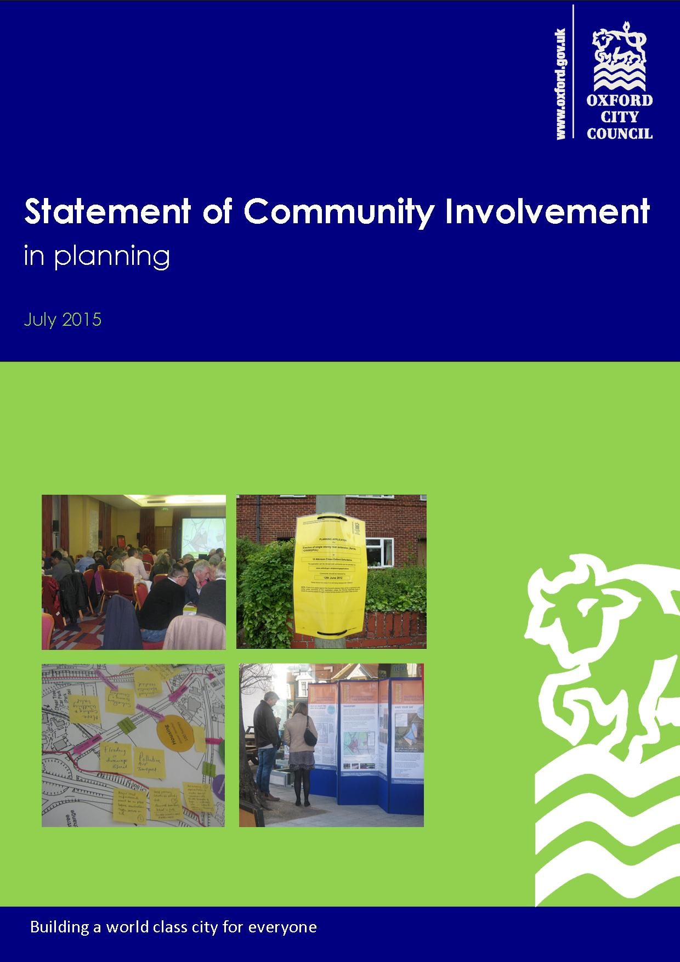
Appendix 1

- Addendum
May 2020

Statement of Community Involvement in Planning (SCI) – Addendum May 2020

Amended Practice in Response to Covid-19 Pandemic

Contents

1. Introduction 4
2. Involving the Community at the Planning Application Stage 5
Decision Making Process 5
Hard Copy Documents 5
Site Visits 5
3. Involving the Community in Planning Policy 6
I - Making Documents and associated information available online 6
II - Notification to all individuals, businesses and organisations on our Local Plan databases 6
III - Public notices at normal deposit points and the Town Hall 7
IV - Public Notice in Local Newspapers 7
V - Press Releases 7
VI - Social Media 7
4. Neighbourhood Planning 8
5. Approaches in the Adopted SCIP where a revised approach in response to COVID-19 Pandemic is now applied. 9

Introduction

  - Oxford City Council is committed to keeping essential services running through the developing Coronavirus (COVID-19) pandemic. It is important that the planning process continues to move forward as planning has an important role to play in supporting our communities and economy. Our Planning service is adapting its approach to planning decisions and plan making in a number of ways in light of COVID-19 restrictions.

  - The Statement of Community Involvement in Planning 2015 (SCI) sets out how we will involve the community in the planning process. This document provides an addendum to the SCI, and sets out the measures the Council will be taking in the Planning Service whilst Covid-19 related restrictions are in force. It sets temporary measures that are being put in place to minimise the impacts of the restrictions on people engaging with the planning process.

  - This addendum and the temporary measures contained within it will only apply until the UK government removes social distancing measures and/or advises that the City Council offices and deposit points can be opened to visitors again. It should be read alongside the original document, available to view at:
https://www.oxford.gov.uk/downloads/file/1474/statement_of_community_involvement
More information on the SCI can also be found on our website at:
https://www.oxford.gov.uk/info/20007/communities/816/community_involvement_in_planning

  - For more general information and guidance about the impact of COVID-19 on Oxford City Council’s services, please visit: https://www.oxford.gov.uk/coronavirus .

Involving the Community at the Planning Application Stage

Decision Making Process

  - Our Planning service is still determining planning applications during the coronavirus pandemic. We have a robust system to determine applications remotely. We have the technology to be able to do this. We have changed some of our working practices around site notices and site visits and these are set out below. The SCI also encourages effective pre-application engagement and we would encourage applicants to discuss with their case officer the approach to pre-application consultation at the current time to ensure it is effective at informing proposals.

Hard Copy Documents

  - We are currently unable to make available hard copies of planning application documents in either the Council or local libraries as these offices are closed to the public. In certain circumstances, the Council has a statutory duty to make hard copy documents available for inspection at the Council officers and at other locations. In the current circumstances, these documents will be available on the Council website. The public will still be advised of relevant applications by site notices and/or press notices. In addition every planning application has an appointed case officer that the public can contact should residents encounter any issues in accessing these documents.

Site Visits

  - As part of the current government advice on social distancing, officers are minimising site visits to properties.

  - However officers are currently reviewing what information they have available to them to make a decision, whether this be by doing site visits from the public realm, reviewing planning histories, and contacting applicants to undertake virtual site visits by requesting photographs with guidance from the officers. This is not the case for all applications but applicants may be asked to provide photographs. Any site visits that we do carry out and where access onto site is essential this will be governed by social distancing requirements and you will be asked a series of triage questions in advance of the visit being arranged.

Involving the Community in Planning Policy

  - The Government is encouraging all local planning authorities to continue, as much as possible, to work proactively with their community and other stakeholders to progress plans. The Planning Advisory Service advise that, ‘This is an opportunity to think differently about how you consult and how you use the online and virtual tools you have access to promote your consultation and allow people to get involved.’

  - Some specific changes are needed to our current methods to reflect to government restrictions in place related to Covid-19. Although documents can be made available online, making plan documents available to view at the Council’s Office and other deposit locations is not possible while they are closed to visitors.

  - We also acknowledge that any public consultations on development plan documents and supplementary planning documents that take place during these restrictions may not be able to undertake physical meetings, events etc. which are listed as possible consultation methods in Table 1 and 2 of the SCI. As set out at paragraphs 3.9 and 3.10 in the SCI an appropriate consultation programme for each document is required and this should consider appropriate measures for the individual document being prepared.
  - The following measures will utilised in the absence of being able to deposit hard copies of planning policy documents where set out in paragraph 3.11 of the SCI. These seek to ensure that local people are still able to participate in planning processes and minimise the impact of not being able to make hard copies of planning policy documents in deposit locations. These measures address the consequences of this unavoidable situation and ensure local people continue to be made aware of the progress of the planning policy documents and have access to documents associated with them.

I - Making Documents and associated information available online
  - The City Council will make the relevant documents available online via the OCC’s website.

II - Notification to all individuals, businesses and organisations on our Local Plan databases
  - OCC will inform all persons and organisations on the Local Plan database of formally published policy documents including consultations documents, submission of development plan documents Inspector reports, and final adopted versions of documents. This will indicate how and where the relevant documents can be viewed on OCC’s website. Included within this correspondence will be the contact details of a named officer including phone number and email address which can be used to discuss any problems they may have in accessing documents via the website. Notifications will be sent by email and also by letter to anyone who has not provided an email address previously.

III - Public notices at normal deposit points and the Town Hall
  - A public notice will be posted at the OCC’s main office (St. Aldates Chambers), the Oxford Town Hall and all public libraries listed in the published Statement of Community Involvement as deposit locations. The notices will be posted in a position that can be seen and read from the public highway or other publically accessible vantage point. The notice will inform the reader of the relevant document or consultation and how and where documents can be viewed on OCC’s website. The notice will also give a name, phone number and email address for an officer who can be contacted by any person who is encountering difficulty in accessing the documents online.

IV - Public Notice in Local Newspapers
  - A similar public notice will also be published in the two main local newspapers – the Oxford Mail and the Oxford Times. The notice will inform the reader where the relevant documents are on OCC’s website. The notice will also give a name, phone number and email address for an officer who can be contacted by any person who is encountering difficulty in accessing the documents online.

V - Press Releases
  - A press release will also be published and sent to local media outlets to raise awareness through local news. This will include where relevant documents can be found on OCC’s website. The press release will also give a name, phone number and email address for an officer who can be contacted by any person who is encountering difficulty in accessing the documents online.

VI - Social Media
  - OCC will also disseminate information via other usual social media channels about relevant planning documents and/or consultations. This will include where the relevant documents can be found on OCC’s website and a name, phone number and email address for an officer who can be contacted by any person who is encountering difficulty in accessing the documents online.

Neighbourhood Planning

For Neighbourhood Planning, deposit of documents within the neighbourhood area will also need to take account of government guidance. Any relevant documents should be published online to view. When the relevant qualifying body’s office or other appropriate publicly accessible venues are not available, measures should be put in place by the relevant qualifying body (e.g. a Parish Council or Neighbourhood Forum) to ensure access to assistance, with notices including an email address and phone number, so that anyone having problems viewing the documents can discuss the consultation and seek assistance to view them.

The Ministry of Housing, Community and Local Government have published a new section to the online planning guidance relating to neighbourhood planning specifically about the impact of the Coronavirus pandemic and neighbourhood plans. This will concern those neighbourhood planning groups preparing neighbourhood plans who may be at a stage close to carrying out a public consultation or submitting their plan to the Councils. The guidance also indicates that no referendums can be carried out now until 6 May 2021.

Approaches in the Adopted SCI where a revised approach in response to COVID-19 Pandemic is now applied.

Page | Paragraph | Text in Adopted SCI | Revised Approach in Response to the COVID-19 Pandemic
13 | 3.11 | ‘The latest version of any formally published consultation documents will be available on the City Council website and at relevant deposit points throughout the city;  At examination stage (for local development plan documents), we will tell those who asked to be notified when the document has been submitted to the Secretary of State. We will also publish a consultation summary report on the City Council website and the representations from the pre-submission stage will be made available for public inspection;  the final, adopted versions of documents will be published on the City Council website and at relevant deposit points throughout the city;’ | It is not possible for the Council to make hard copies at the deposit points throughout the city. The City Council will make the relevant documents available online via our website and take the additional temporary measures set out in section 3 of this addendum.
15 | 4.3 – e) | ‘Publicity/submission -consultation Once the neighbourhood planning group has submitted their Neighbourhood Plan to the City Council, the City Council will publish the plan and supporting documents in accordance with the regulatory requirements on the City Council website. Copies of these documents will also be available at the main council offices (St Aldate’s Chambers). The City Council will contact all those who we are advised have commented previously on the Neighbourhood Plan to invite final comments.’ | It is not possible for neighbourhood planning groups to make their plan and supporting documents available to view at the main City Council offices (St Aldate’s Chambers). Instead, the neighbourhood planning group ensure access to assistance, with notices including an email address and phone number, so that anyone having problems viewing the documents can discuss the consultation and seek assistance to view them. Deposit of documents within the neighbourhood area will also need to take account of government guidance.
15 | 4.3 – f) | ‘…The City Council will then publish the Examiner’s report and decision statement on the City Council website, and make it available to view at the City Council’s main offices (St Aldate’s Chambers), before proceeding to arrange (subject to a favourable Examiner’s report) the referendum.’ | It is not possible for the Council to make Neighbourhood Plan Examiner’s reports and decision statements available to view at the City Council’s main offices (St Aldate’s Chambers). The City Council will make the relevant documents available online via our website and neighbourhood planning group should work to ensure access to assistance, with notices including an email address and phone number, so that anyone having problems viewing the documents can discuss the consultation and seek assistance to view them. Deposit of documents within the neighbourhood area will also need to take account of government guidance.
15 | 4.3 – g) | ‘At least 28 days before the referendum takes place, the City Council will publish the following documents on its website (hard copies will also be made available at the main City Council offices, St Aldate’s Chambers): the draft Neighbourhood Plan; the Examiner’s report; a summary of the representations submitted to the Examiner; a statement that the City Council is satisfied that the plan meets the basic conditions; general information on town and country planning to ensure voters have sufficient knowledge to make an informed decision; and an information statement that provides detailed information on the referendum arrangements. The City Council will also encourage the neighbourhood planning group to let local people know about the referendum and encourage a high participation rate so that it is representative’ | Government guidance has stated that no referendums can take place until 6 May 2021 and is therefore unlikely to be affected by current restrictions.
17 | 5.7 | ‘Availability of plans – plans and documents submitted as part of a planning application are available to view online at the main City Council offices (St Aldate’s Chambers) during office hours. Paper copies of documents for major planning applications are available in reception, or for other types of planning application are available to view by making an appointment with the relevant case officer in advance.’ | It is not possible for the Council to make available plans and documents submitted as part of a planning application to view online at the main City Council offices (St Aldate’s Chambers) or provide paper copies of documents for major planning applications. Instead, the City Council will make the relevant documents available online via our website. Every planning application has an appointed and named case officer that the public can contact should residents encounter any issues in accessing these documents. The public will still be advised of relevant applications by site notices and/or press notices.
18 | 5.8 | ‘Before recommending a decision, the planning officer will make a full site inspection and take account of any comments received from neighbours, interested bodies, and statutory consultees’ | As part of the current government advice on social distancing, officers are not making site visits to properties.  However, officers are currently reviewing what information they have available to them to make a decision, whether this be by doing site visits from the public realm, reviewing planning histories, and contacting applicants to undertake virtual site visits by requesting photographs with guidance from the officers. This is not the case for all applications but applicants may be asked to provide photographs.
19 | 5.13 | ‘Reports for applications being determined at committee are available for public inspection at the City Council’s main offices (St Aldate’s Chambers) and on the City Council website usually one week before the committee meeting.’ | Reports for applications being determined at committee are not currently available for public inspection at the City Council’s main offices (St Aldate’s Chambers).  Instead, these reports are available online to view via our website. Every planning application has an appointed and named case officer that the public can contact should residents encounter any issues in accessing these documents.

https://www.gov.uk/guidance/neighbourhood-planning--2#covid-19
The revised approach will only replace the adopted approach where COVID-19 pandemic restrictions deem these revised measures necessary. Once the government’s advice on the COVID-19 pandemic restrictions changes to allow the adopted approach, those relevant paragraphs will be reinstated.

